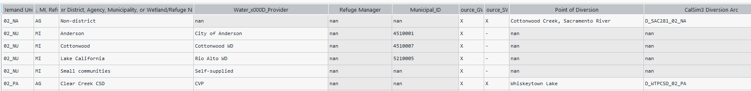

* Drop non-Ag Demand Units from excel
  + The number of DU goes from 387 to 149
* Drop duplicate demand units
  + The number of DU goes from 149 to 144
* Drop ag DU that don’t have delivery variable
  + The number of DU goes from 144 to 134

* Get delivery variables
  + drop duplicates and nan
  + some demand units have 2 delivery variables thus we separate them
* From DSS get the time series for each delivery variable and save it in csv
  + Extract metadata of delivery variables for each demand unit in dic
  + then get time series for each delivery variable from dss
    - there's 3 we don’t time series

* Thus, 3 demand units we don’t have delivery variables
  + The number of DU that we have delivery is 131, out of 144.

Summary:

I’ve compiled deliveries (time series) for ag demand units based on the excel file which has listed the delivery variable for each demand unit.

Findings

Out of 149 demand units

* 5 have been dropped because demand units were duplicated. (this is because some demand units have 2 water agencies)
* Another 10 have been dropped because no delivery variable is listed.

Thus, we are left with 134 that demand units that have delivery variables:

* 3 misclassified (we don’t have delivery variable in DSS): 2 GW, 1 diversion.
  + 60S_NA1
    - Delivery Variable: DN_60S_NA1 missing
    - This should be GW pumping (GP +RU)
    - I looked for other variables that contain 60S_NA1:

* + 60S_NA2
    - Delivery Variable: DN_60S_NA2 missing
    - This should be GW pumping (GP +RU)
    - I looked for other variables that contain 60S_NA2:

* + 71_PA7
    - Delivery Variable: DN_71_PA7 missing
    - Here we have to use diversion?
    - I looked for other variables that contain 71_PA7:

Extra:

* What is this node?
  + Why are we using diversion delivery variable for this DU?



These are the other variables:

* Do I stick to the delivery variables listed on the excel? If not, what delivery variable should I use for each demand unit?

|  |  |  |
| --- | --- | --- |
| Source | Delivery Variable | Notes |
| Groundwater only | GP and RU | RU is not everywhere, correct?  In excel, not all have RU.  It shouldnt have DN. |
| Surface only | DN |  |
| GW and Surface | DN | do we add GP as well?  In excel, those that have both sources have DN as delivery variable |

* 71_NA3 is listed as groundwater only but the delivery variable is DN_. And we have that, does this mean this has been misclassified as well?



* Demand units that have 2 delivery variables listed. Some are separated with plus sign others with semicolon.
  + It means the same thing, correct?